Paired Reading Fluency Check
Reader’s name:
Evaluator’s name:
Name of Text:
Reading 1: How did my partner read the first time? (Reader circle face)
 |  |  | 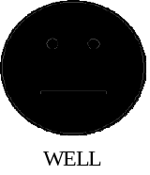 | 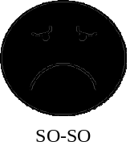 | 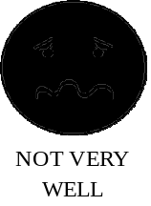
Suggestions: Check the suggestions that best apply to your partner.
 | Remember to read a little faster.
 | Remember to read a little slower.
 | Remember to read with expression
 | Remember to pause at the end of a comma and stop at the end of a period.
 | You forgot the words ____________, _____________, and __________.
 | Next time remember to say _____________, not _______________.
 | Remember to say the ending of words. For example, the letter “s” in the word, “reads”

Reading 2: How did my partner read the second time? (Reader circle face)
Suggestions: Check the suggestions that best apply to your partner.
Remember to read a little faster.
Remember to read a little slower.
Remember to read with expression
Remember to pause at the end of a comma and stop at the end of a period.
You forgot the words ____________, _____________, and __________.
Next time remember to say _____________, not _______________.
Remember to say the ending of words. For example, the letter “s” in the word, “reads”
Notes for my partner:

